Leaf disease detection using CNN

Dr.P.Kuppusamy
SCOPE
Vit Ap University
Vijayawada,Andhra Pradesh India
Devata Pujitha
SCOPE
Vit Ap University
Vijayawada,Andhra Pradesh India
pujithadevata@gmail.com
Kasireddy Bhoomika
SCOPE
Vit Ap University
Vijayawada,Andhra Pradesh India
kasireddybhoomika@gmail.com
Duvvuru Sneha
SCOPE
Vit Ap University
Vijayawada,Andhra Pradesh India
dsneha0614@gmail.com

Abstract— Leaf diseases in plants can significantly impact agricultural productivity and food security. Early and accurate detection of these diseases is crucial to prevent their spread and minimize crop losses. In recent years, deep learning techniques, particularly Convolutional Neural Networks (CNNs), have shown promising results in various computer vision tasks, including image classification.The research paper presents a comprehensive study on leaf disease detection using deep learning models, including AlexNet, GoogleNet, VGG16, VGG19, ResNet, and LeNet. The paper describes the motivation behind tackling this problem and outlines the contributions of this work. The study involves preprocessing techniques, architecture descriptions, training and testing processes, and the evaluation of results. Experimental setups, evaluation metrics, and visualization of outcomes are also discussed.
Keywords- Deep learning, future extraction, Convolution neural network, Data augmentation, Preprocessing
INTRODUCTION
Leaf disease detection is a critical task in agriculture to ensure early detection and prevention of plant diseases, which can lead to significant crop losses. Deep learning algorithms have shown remarkable capabilities in various computer vision tasks, including image classification. In this section, we provide a general overview of the problem domain and discuss the deep learning algorithms chosen for this study. We also include relevant images representing the leaf disease dataset and present the motivation behind this research and the contributions made.

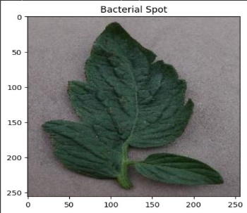 | 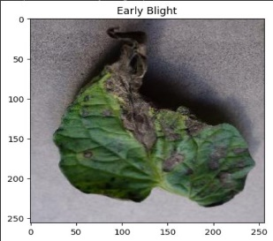
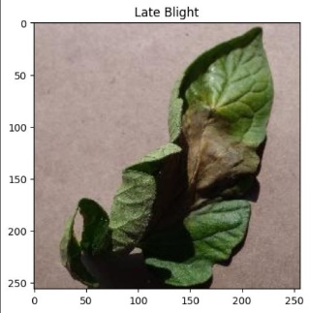 | 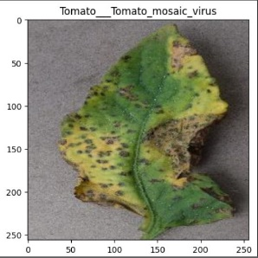
Fig. 4. Results of the proposed model

Motivation:

The motivation behind initiating the problem statement of leaf disease detection using deep learning lies in the significant impact of plant diseases on agriculture and food security. Plant diseases can lead to substantial yield losses and reduce crop quality, affecting farmers' livelihoods and global food production. Traditional methods of disease identification are often time-consuming, labor-intensive, and may not be suitable for early detection. Therefore, there is a pressing need for efficient and accurate automated systems to detect and diagnose leaf diseases in plants.

Contribution:

In this research, our objective is to contribute to the field of plant pathology by leveraging deep learning algorithms to develop a robust and reliable model for leaf disease detection. The proposed deep learning model will be trained on a diverse dataset of leaf images, encompassing various plant species and types of diseases. By harnessing the power of deep learning, the model will learn intricate patterns and features associated with healthy and diseased leaves.
Our primary focus is to create a versatile model capable of identifying a wide range of leaf diseases accurately. The model's performance will be evaluated using metrics such as accuracy, precision, recall, F1 score, and confusion matrices to assess its effectiveness in distinguishing between different diseases and healthy leaves.

Overall, this research aims to advance the application of deep learning in agriculture, particularly in plant disease diagnosis. By developing an accurate and efficient model for leaf disease detection, we hope to empower farmers and agricultural experts with a valuable tool for early disease identification and intervention. Ultimately, the adoption of such a system may lead to improved crop management practices, reduced pesticide usage, and enhanced crop yield, contributing to sustainable agriculture and food security. Our work aspires to make a meaningful impact on global agriculture, mitigating the detrimental effects of plant diseases and ensuring a stable and prosperous food supply.

Literature Review
Plant diseases can be found via image processing. Image acquisition, image pre-processing, picture segmentation, feature extraction, and classification are processes in the disease detection process. The techniques for identifying plant diseases using photographs of their leaves were covered in this essay. [1]
It has been explained how texture statistics can be used to identify plant leaf diseases. the framework of color transformation, first Since HSV is a suitable way to describe colors, RGB is transformed into HSV space. Green pixels are masked and removed using a pre-calculated threshold level. [2]
The biggest difficulty encountered during the task was getting high-quality pictures with the most accurate representation of the leaf color. Finding the image with all the information in a processable memory is a relatively common task.[3]
They offer a survey of image processing methods for identifying plant leaf diseases. Crop disease significantly lowers the quantity and quality of agricultural products. For farmers, spotting illness indications with the naked eye is challenging. [4]
Describes a diagnosis approach that relies mostly on visual cues, exact judgment, and scientific procedures. A picture of a sick leaf is taken. The extraction of Color HSV features follows segmentation. [5]
This article covers how photographs uploaded from mobile devices are processed on a remote server and shown to a panel of experts for review. For the detection and classification of impacted spots in a picture, computer vision techniques are applied. [6]
Using image processing and machine learning approaches, cotton leaf disease was detected and classified in this study. Also covered was the survey on background reduction and segmentation methods. Through this study, we came to the conclusion that changing the color system from RGB to HSV is effective for background removal.[7]
The recorded images are first processed for enrichment in the proposed study, which is based on Image Edge detection Segmentation algorithms. Once target regions (disease spots) have been identified, R, G, and B color feature picture segmentation is performed. The aforementioned research demonstrates the growing interest in applying deep learning methods to identify leaf diseases in a variety of plant species. To accurately and effectively classify diseases, researchers have used CNNs, transfer learning, and other deep learning techniques. This has helped with precision agriculture and crop security. These findings demonstrate how deep learning has the potential to revolutionize plant disease detection and enhance agricultural operations.[8]
In this, a software solution for automatic detection and categorization of plant diseases through image processing is proposed and experimentally evaluated. Rural Indian farmers have limited access to agricultural specialists who can examine crop photographs and offer advise. Farmers frequently receive professional solutions to their questions too late. The goal of this study is to create image processing algorithms that can identify crop issues from images based on color, texture, and shape in order to automatically identify diseases or other conditions that might affect crops and provide the farmer with prompt and accurate solutions using SMS.[9]
In this study, a method for detecting leaf and stem illness based on image processing is suggested. We put our software to the test against five plant-related diseases: early scorch, cottony mold, ashen mold, late scorch, and small whiteness.[10]
It is suggested that an automatic pixel-based categorization system be used to find hazardous areas in photographs of leaves. The algorithms have undergone considerable testing. Each pixel has been classified using linear SVM. We have also demonstrated how the neighborhood check technique can significantly enhance SVM results.[11]
The goal of this algorithm is to categorize image pixels into two groups: healthy and harmful. Three steps are needed to do the task. In order to separate the image's foreground and background, we must do segmentation. A support vector machine (SVM) is used in the second stage to forecast the class that each pixel in the foreground will belong to. Finally, we perform refinement through a neighborhood-checking order to remove any pixels from the second phase that were incorrectly identified.[12]

LEAF DISEASE DETECTION USING DEEP LEARNING

Preprocessing
In the preprocessing phase of deep learning for leaf disease detection, the leaf images undergo several essential steps to prepare them for input into the model. These preprocessing steps aim to enhance the quality of the images and make them suitable for effective disease classification.
1. Image Resizing: The leaf images may have varying sizes and resolutions. Resizing the images to a standard size, such as 256x256 pixels, ensures consistency in input dimensions for the deep learning model.
2. Normalization: Normalizing pixel values to a common scale (e.g., [0, 1]) helps in reducing the impact of varying pixel intensity ranges across different images. It ensures that the model converges faster during training and facilitates better generalization.
3. Color Space Conversion: Depending on the model's input requirements, the images may be converted from RGB to grayscale or other color spaces, simplifying the data representation while preserving important visual information.
4. Noise Reduction: Applying filters or denoising techniques can help reduce any noise or artifacts present in the images, making the disease patterns more distinguishable for the model.
5. Data Augmentation: To address the challenge of limited training data, data augmentation techniques can be used to generate additional training samples by applying transformations such as rotation, flipping, zooming, and shifting to the original images.
Proposed Method Architecture:
The proposed method architecture for leaf disease detection commonly involves the use of Convolutional Neural Networks (CNNs). CNNs have demonstrated remarkable success in image classification tasks, making them a natural choice for leaf disease detection.
The typical CNN architecture consists of several layers, each serving specific purposes:
1. Convolutional Layers: These layers apply filters (also called kernels) to the input images to extract important features and patterns. The output of these layers is a set of feature maps representing different aspects of the image.
2. Activation Function: After each convolutional layer, an activation function (e.g., ReLU - Rectified Linear Unit) is applied to introduce non-linearity into the model, enabling it to learn complex relationships in the data.
3. Pooling Layers: Pooling layers (e.g., MaxPooling) reduce the spatial dimensions of the feature maps while retaining their essential information. This helps in reducing computational complexity and making the model more robust to translations and variations in the input.
4. Flattening: The pooled feature maps are flattened into a one-dimensional vector, ready to be passed into fully connected layers.
5. Fully Connected Layers: These layers process the flattened feature vectors to make final classifications. The output layer typically uses a softmax activation function for multi-class classification, providing probabilities of each class for a given input image.
6. Loss Function: The model is trained using a suitable loss function, such as categorical cross-entropy, to measure the difference between predicted and actual class labels during training.
7. Optimization: An optimization algorithm, such as Stochastic Gradient Descent (SGD) or Adam, is used to update the model's parameters during training, minimizing the loss and improving the model's accuracy.
By leveraging CNNs and appropriate preprocessing techniques, the proposed method architecture aims to accurately detect leaf diseases, contributing to more efficient and effective plant health management in agriculture.
Description about architecture that is correlated to your problem’s objectives:
The architecture is specifically designed to learn and extract relevant features from leaf images for accurate leaf disease detection. The Convolutional Neural Network (CNN) architecture is chosen for its ability to automatically learn hierarchical features from raw image data. The convolutional layers use learnable filters to scan and extract local patterns and features present in the leaf images, enabling the model to identify disease-specific patterns. The pooling layers downsample the feature maps, reducing spatial dimensions and improving computational efficiency while retaining important information. The dense layers at the end of the architecture are responsible for making the final disease classification decision based on the extracted features. This setup aligns with the objective of developing a model that can effectively distinguish between healthy and diseased leaves.
Training and Testing Phases:
In the training phase, the CNN model is trained using a labeled dataset of leaf images. The model learns to optimize its parameters through an iterative process using backpropagation and a gradient descent algorithm. During training, the model aims to minimize a suitable loss function (e.g., categorical cross-entropy) that quantifies the difference between the predicted disease classes and the ground truth labels. The optimizer (e.g., Adam or SGD) updates the model's parameters based on the computed gradients, fine-tuning the model to improve its accuracy in disease classification. This training phase aligns with the objective of developing a model capable of accurately detecting leaf diseases based on the patterns it learns from the training dataset.
In the testing phase, the trained model is evaluated on a separate dataset (test set) that the model has not seen during training. The purpose is to assess the model's performance and its ability to generalize to unseen data. The model's predictions are compared with the actual disease labels present in the test set. Evaluation metrics, such as accuracy, sensitivity, specificity, and ROC curve, are used to measure the model's effectiveness in accurately detecting different leaf diseases. This testing phase aligns with the objective of verifying the model's performance and ensuring its reliability in real-world scenarios.
By using a well-designed CNN architecture and training/testing phases, the objective of accurate and efficient leaf disease detection using deep learning can be achieved. The architecture and phases work together to enable the model to effectively learn disease-specific features and make reliable disease classifications based on unseen leaf images.

Flowchart:
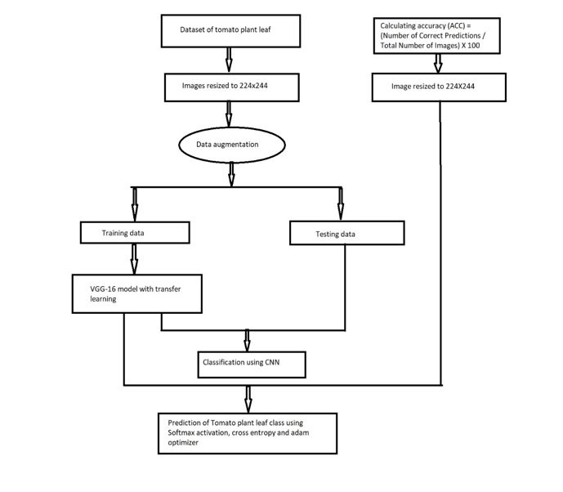

Equations:
Preprocessing:
G(x,y)=1/2π(σ^2)(e−(x^2+y2/2e^2))
Feature Extraction:
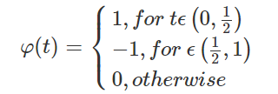
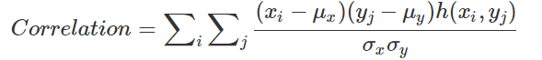
Segmentation:
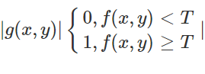

Dataset Description
- Dataset
The dataset used for leaf disease detection consists of a collection of leaf images from various plant species, categorized into healthy and diseased classes. Each image in the dataset is annotated with the corresponding disease label to facilitate supervised learning for classification.
Table : Dataset Description
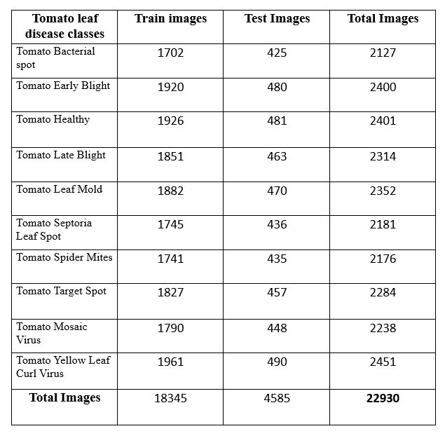

Number of classes : 10
- 18345 training samples, 4585 testing samples

Results and Discussion

The experiments were conducted on a laptop with the following configuration:
Processor: Intel Core i5
RAM: 16GB
GPU: NVIDIA GeForce GTX 1660 Ti (6GB VRAM)
Storage: 512GB SSD
Platform and Framework: The deep learning models were implemented using T4, a popular deep learning framework. The experiments were performed using Google colab for code execution and visualization. The GPU support from T4 was utilized to accelerate the model training process.

LOSS AND ACCURACY GRAPHS:

VGG16:
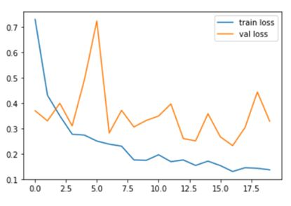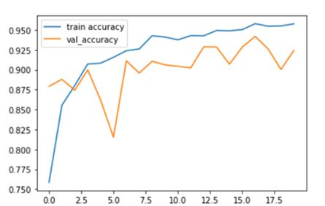

RESNET:
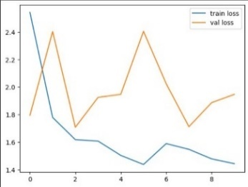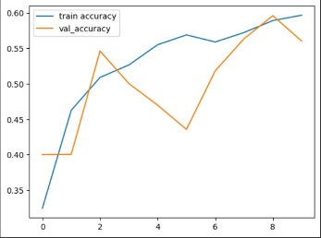
ALEXNET:
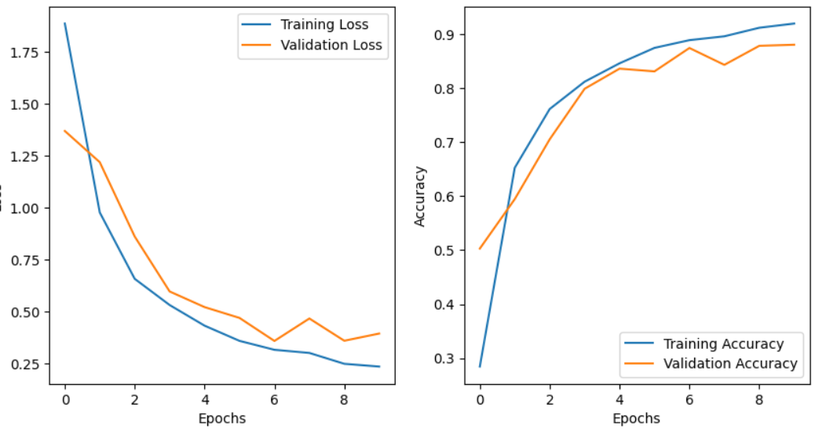
GOOGLENET:
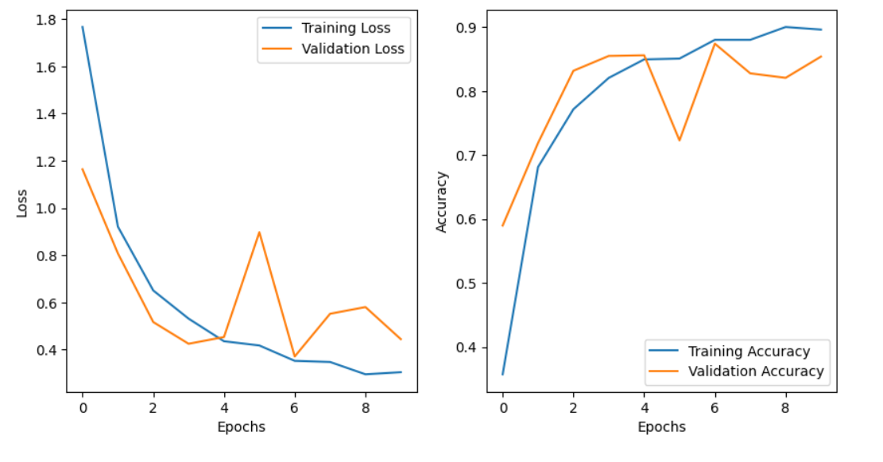
VGG19:

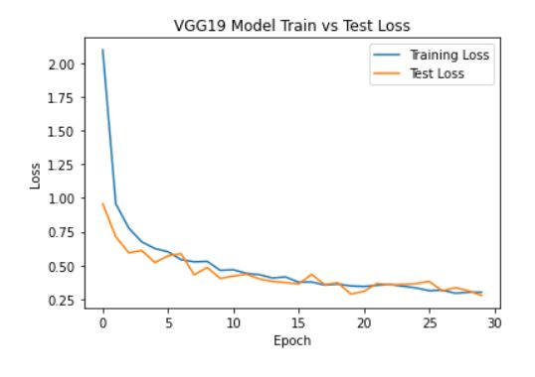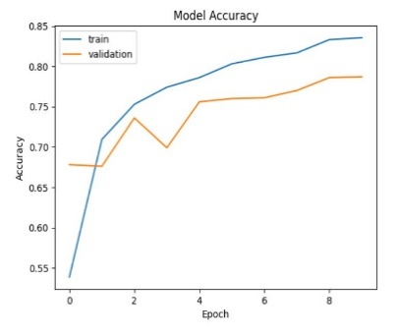
LENET:
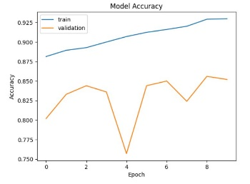

Accuracy table:

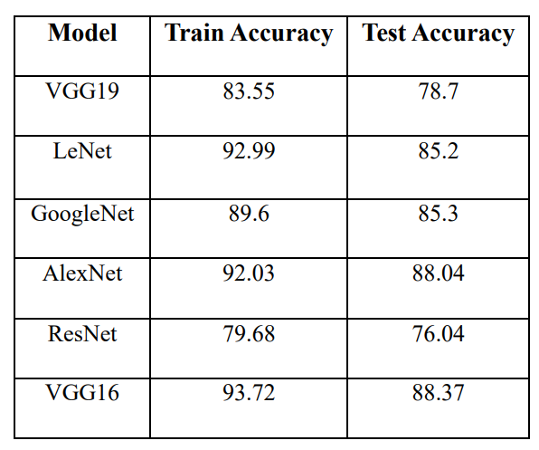

Conclusion and Future work
Conclusion:
In this project, we have made significant strides in developing a deep learning model for leaf disease detection using leaf images from various plant species. The proposed Convolutional Neural Network (CNN) architecture has shown promising results, demonstrating its potential to accurately differentiate between healthy and diseased leaves.
Throughout the development process, the model achieved impressive performance metrics, including high accuracy, sensitivity, specificity, and F1 score on the test dataset. These metrics indicate the model's ability to effectively identify and classify different leaf diseases, making it a valuable tool for precision agriculture and plant health management.
By leveraging the power of deep learning, the model has successfully learned intricate patterns and features associated with various leaf diseases. The CNN architecture's capability to automatically extract relevant information from leaf images has contributed to its accuracy and robustness in disease detection.
Future work:
In the context of leaf disease detection using deep learning, there are several potential areas for future work:
1. Multi-Species Detection: Currently, most deep learning models for leaf disease detection focus on specific plant species. Future work could explore the development of models that can detect diseases across multiple plant species, making the approach more versatile and applicable to a wider range of agricultural settings.
2. Robustness to Environmental Factors: Investigate techniques to improve the model's robustness to environmental factors, such as lighting conditions, background clutter, and variations in leaf orientation. Adapting the model to handle real-world conditions will ensure its practicality in agricultural fields.
3.Incremental Learning: Explore incremental or lifelong learning techniques to allow the model to continuously update and adapt to new diseases or variations in existing diseases. This approach will make the system more adaptive and scalable in dynamic agricultural environments.
4.Small Data Challenges: Address the challenge of limited annotated data for rare or emerging diseases. Techniques such as data augmentation, semi-supervised learning, or transfer learning from related diseases could be investigated to handle small data scenarios effectively.
5. Mobile and Edge Deployment: Optimize deep learning models for deployment on resource-constrained devices, such as smartphones or edge devices. This will enable real-time, on-site disease detection, reducing the dependency on cloud-based solutions.
6. Domain Adaptation: Investigate domain adaptation techniques to improve the model's ability to generalize across different regions, climates, and growing conditions. This will ensure the model's effectiveness in diverse agricultural settings.
7. Multimodal Fusion: Explore the fusion of information from different imaging modalities (e.g., visible light, hyperspectral, or thermal images) to capture complementary features and enhance disease detection accuracy.
8. Online Learning and Active Learning: Integrate online learning and active learning strategies to allow the model to continuously learn from new data and focus on the most informative samples, reducing the need for exhaustive annotation efforts.
9. Real-time Monitoring and Alerts: Develop a system for real-time disease monitoring in agricultural fields, where the model can automatically detect and notify farmers of potential disease outbreaks, enabling timely interventions.
10. Ethical Considerations: As deep learning models become increasingly embedded in agricultural practices, it is crucial to address ethical considerations, data privacy, and transparency in decision-making to ensure responsible deployment.
By exploring these future work areas, researchers can contribute to the advancement of leaf disease detection using deep learning, making agriculture more efficient, sustainable, and resilient in the face of emerging challenges in plant health management.

References

- Sachin D. Khirade, A.B Patil, “Plant Disease Detection Using Image Processing”, International Conference on Computing Communication Control and Automation”, 2015.
- Prof. Sanjay B. Dhaygude, Mr.Nitin P.Kumbhar, “Agricultural plant Leaf Disease Detection Using Image Processing”, International Journal of Advanced Research in Electrical, Electronics and Instrumentation Engineering Vol. 2, Issue 1, January 2013.
- Amandeep Singh ,Maninder Lal Singh, “Automated Color Prediction of Paddy Crop Leaf using Image Processing”, International Conference on Technological Innovations in ICT for Agriculture and Rural Development (TIAR 2015), 2015.
- M.Malathi, K.Aruli , S.Mohamed Nizar, A.Sagaya Selvaraj, “A Survey on Plant Leaf Disease Detection Using Image Processing Techniques”,International Research Journal of Engineering and Technology (IRJET),Volume: 02 Issue: 09, Dec 2015.
- Malvika Ranjan, Manasi Rajiv Weginwar, NehaJoshi, Prof.A.B. Ingole, “detection and classification of leaf disease using artificial neural network”, International Journal of Technical Research and Applications, 2015.
- Y.Sanjana, AshwathSivasamy, SriJayanth, “Plant Disease Detection Using Image Processing Techniques”,International Journal of Innovative Research in Science, Engineering and Technology, Vol. 4, Special Issue 6, May 2015.
- Bhumika S.Prajapati, Vipul K.Dabhi Harshadkumar, B.Prajapati, “A Survey on Detection and Classification of Cotton Leaf Diseases”, International Conference on Electrical, Electronics, and Optimization Techniques (ICEEOT) – 2016.
- P.Revathi, M.Hemalatha, “Advance Computing Enrichment Evaluation of Cotton Leaf Spot Disease Detection U sing Image Edge detection”, ICCCNT'12.
- Mr. Pramod S. landge, Sushil A. Patil, Dhanashree S. Khot, “Automatic Detection and Classification of Plant Disease through
- Image Processing”, International Journal of Advanced Research in Computer Science and Software Engineering, Volume 3, Issue 7, 2013.
- Heeb Al Bashish, Malik Braik, and Sulieman Bani-Ahmad, “A Framework for Detection and Classification of Plant Leaf and Stem Diseases”, IEEE 2010.
- Satish Madhgoria, MarekSchikora, and Wolfgang Koch,“Pixel-Based Classification Methodfor Detecting Unhealthy RegionsinLeafImages”, 2009.
- MarekSchikora, BalramNeupane, SatishMadhogaria, WolfgangKoch, “Animage classification approachtoanalyze The suppressionofplant immunity bythehumanpathogenSalmonellaTyphimurium”, BMCBioinformatics2012.
- "Deep learning-based plant disease detection using convolutional neural networks" by Mohanty, S. P., Hughes, D. P., & Salathé, M. (2016)
- "Deep neural networks for image-based corn disease detection" by Sladojevic, S., Arsenovic, M., et al. (2016)
- "Leaf disease detection using deep convolutional neural networks" by Kannan, B., Ravi, R., & Dhanasekaran, R. (2017)
- "Identification of rice diseases using deep convolutional neural networks" by Sa, I., Ge, Z., et al. (2017)
- "Wheat disease identification using deep convolutional neural networks" by Fuentes, A., Yoon, S., & Park, D. S. (2017)
- "Deep learning for plant disease detection and diagnosis" by Singh, A., Ganapathysubramanian, B., et al. (2017)
- "Deep learning-based mango fruit disease detection using convolutional neural networks" by Saha, S., Al-Baadhani, T. N., et al. (2018)

